

UNIVERSITI MALAYSIA TERENGGANU

**Faculty of Computer Science and Mathematics**

**CSM3103 – FRONT-END PROGRAMMING**

**Mobile Application Proposal**

**YippyYap: Eats Streak**

**Prepared by:**

**ARIF AFIFY BIN SULAIMAN**

**(S67610)**

**Prepared for:**

DR RABIEI BIN MAMAT

BACHELOR OF COMPUTER SCIENCE(MOBILE COMPUTING) WITH HONOURS

**Semester II 2023/2024**

**Individual Project Proposal: "YippyYap: Eats Streak"**

**Introduction**

YippyYap: Eats Streak is a proposed mobile application designed to streamline the student dining experience at academic institutions. This user-friendly platform aims to enhance efficiency in locating and selecting food options by collecting information on nearby food trucks and on-campus dining specials. YippyYap puts all your daily dining options in one place, saving you time and helping you find the perfect bite.

**Problem Statement**

**Dificulty in Making Decision:**

Students waste valuable time browsing social media, flyers, and various apps to find lunch or dinner options. YippyYap eliminates the need for endless searching, allowing students to focus on enjoying a delicious meal while spent more time studying.

**It is Hard to find Hidden Gems:**

Many delicious and budget-friendly vendors visit campus, but students may not be aware of them due to a lack of centralized information. YippyYap exposes these hidden gems, ensuring students discover exciting culinary experiences readily available on campus.

**Missed Deals and Promotion regularly:**

Dining halls and cafes often offer daily specials, but these deals go unnoticed by students due to inadequate or inefficient promotional strategies. YippyYap keeps students informed about all the delicious and budget-conscious options available, allowing them to make the most of their dining experiences.

**Objectives**

**One-Stop Platform:**

Provides a curated list of nearby food trucks, including cuisine type, current location, and menus. This allows students to browse a variety of options and make informed choices based on their preferences.

**Provide Easy Discovery:**

Utilizes location services to display nearby and operational food trucks on the main screen. Students can easily see what's available in their immediate vicinity, eliminating the need for extensive searching.

**Real-Time Updates:**

Vendors can register and update their location and menus in real-time within the app. Students can access the latest information, ensuring they find accurate details about nearby vendors and their offerings.

**Wireframe**

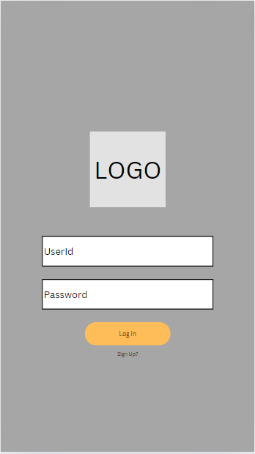

Figure1:Wireframe of the project

Figure 1 shows the interface of this project. It highlight the login page that is necessary to identify the user.User need to fill in UserID and Password to login. In this page potential user can also SignUp for a new account to enable them to buse this project.

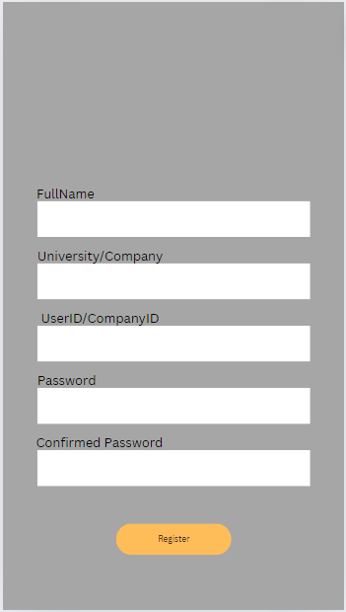

Figure2:Wireframe of the project

Figure 2 shows the interface of this project. It shows the registration form that pops up after SignUp link is clicked.It ask for user detailed to identify user data so that the platform can function at its best form.

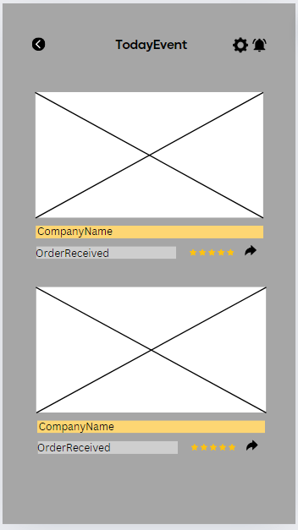

Figure3:Wireframe of the project

Figure 3 shows the interface of this project. This part highlight the main page of the application. It shows user what is available during the day. User also can rate the Seller using 5star review to recommend others to experience the same feelings, not only that the user can share seller post so that the post can reach a higher audience. User also can set alert to the post so they will be notified for the seller promotion and sales.

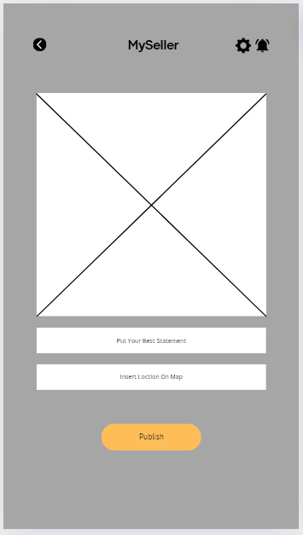

Figure4:Wireframe of the project

Figure 4 shows the interface of this project.This part shows that seller can upload their product and link to the google map so that other user(student/customer) can reach out to them.